3. PRODUCT DATASET INTEGRATION USING PYTHON
Aim
To clean and integrate Supplier, Warehouse, and Online Store product datasets by handling duplicates, invalid product codes, spelling errors, inconsistent categories, price outliers, missing values, and numerical formatting issues using Python.

Dataset Description
The three datasets contain product information from different sources.
Supplier Dataset: Product Name, Product Code, Price, Category
Warehouse Dataset: Product Name, Product Code, Stock Quantity, Warehouse
Online Store Dataset: Product Name, Product Code, Price, Category, Stock Quantity
The datasets may contain inconsistencies such as:
- Wireless Mouse and wireless mouse
- Bluetooth Speaker and Bluetooh Speaker
- ELEC-1001 and invalid codes such as ELEC1001
- Duplicate records
- Different category names such as Electronics, electronic, and Electronics & Gadgets
- Missing values
- Unusually high or low prices

Python Program
import pandas as pd
import re
from rapidfuzz import fuzz
# Load datasets
supplier = pd.read_csv("supplier.csv")
warehouse = pd.read_csv("warehouse.csv")
online = pd.read_csv("online_store.csv")

# Product name standardization
def clean_name(name):
name = str(name).strip()
name = re.sub(r'\s+', ' ', name)
return name.title()
for df in [supplier, warehouse, online]:
df["Product Name"] = df["Product Name"].apply(clean_name)
# RegEx validation of Product Code
pattern = r"^[A-Z]+-\d{4}$"
for df in [supplier, warehouse, online]:
df["Valid Code"] = df["Product Code"].apply(
lambda x: bool(re.match(pattern, str(x)))
)
# Remove invalid product codes
supplier = supplier[supplier["Valid Code"]]
warehouse = warehouse[warehouse["Valid Code"]]
online = online[online["Valid Code"]]
# Remove duplicate records
supplier = supplier.drop_duplicates(subset="Product Code")
warehouse = warehouse.drop_duplicates(subset="Product Code")
online = online.drop_duplicates(subset="Product Code")
# Standardize categories
category_map = {
"electronic": "Electronics",
"electronics": "Electronics",
"electronics & gadgets": "Electronics",
"accessories": "Accessories",
"accessory": "Accessories",
"home": "Home",
"home & kitchen": "Home"
}
for df in [supplier, online]:
df["Category"] = (
df["Category"]
.astype(str)
.str.strip()
.str.lower()
.map(category_map)
.fillna("Other")
)
# Normalize numerical values
for df in [supplier, online]:
df["Price"] = pd.to_numeric(
df["Price"], errors="coerce"
)
for df in [warehouse, online]:
df["Stock Quantity"] = pd.to_numeric(
df["Stock Quantity"], errors="coerce"
)
# Handle missing values
supplier["Price"] = supplier["Price"].fillna(
supplier["Price"].median()
)
warehouse["Stock Quantity"] = warehouse[
"Stock Quantity"
].fillna(0)
online["Price"] = online["Price"].fillna(
online["Price"].median()
)
online["Stock Quantity"] = online[
"Stock Quantity"
].fillna(0)
# Fuzzy matching of product names
for i in range(len(warehouse)):
for j in range(i + 1, len(warehouse)):
score = fuzz.ratio(
warehouse.iloc[i]["Product Name"],
warehouse.iloc[j]["Product Name"]
)
if score >= 85:
print(
"Similar Products:",
warehouse.iloc[i]["Product Name"],
"and",
warehouse.iloc[j]["Product Name"],
"Score:",
score
)
# Price outlier detection using IQR
Q1 = supplier["Price"].quantile(0.25)
Q3 = supplier["Price"].quantile(0.75)
IQR = Q3 - Q1
lower = Q1 - 1.5 * IQR
upper = Q3 + 1.5 * IQ
supplier["Price Outlier"] = (
(supplier["Price"] < lower) |
(supplier["Price"] > upper)
)
# Integrate the datasets
master = pd.merge(
supplier,
warehouse[
["Product Code", "Stock Quantity", "Warehouse"]
],
on="Product Code",
how="outer"
)
master = pd.merge(
master,
online[
["Product Code", "Price", "Category"]
],
on="Product Code",
how="outer",
suffixes=("_Supplier", "_Online")
)
# Create final values
master["Final Price"] = master[
"Price_Supplier"
].combine_first(master["Price_Online"])
master["Final Category"] = master[
"Category_Supplier"
].combine_first(master["Category_Online"])
master["Final Stock"] = master[
"Stock Quantity"
].fillna(0)
# Select final columns
product_master = master[
[
"Product Code",
"Product Name",
"Final Price",
"Final Category",
"Final Stock",
"Warehouse"
]
]
product_master = product_master.drop_duplicates(
subset="Product Code"
)
# Export files
product_master.to_csv(
"product_master.csv",
index=False
)
product_master.to_json(
"product_master.json",
orient="records",
indent=4
)
print("\nFinal Product Master:")
print(product_master)
print("\nCSV and JSON files created successfully.")

Important Techniques Used
1. RegEx Validation
RegEx is used to check whether the product code follows the required format.
r"^[A-Z]+-\d{4}$"
Example of a valid code:
ELEC-1001
Invalid examples:
ELEC1001
ELEC-101
ELEC-ABCD

2. Fuzzy Matching
Fuzzy matching identifies product names that are similar even when there is a spelling mistake.
Example:
Bluetooth Speaker
Bluetooh Speaker
A similarity score of 85 or above is treated as a possible match.

3. Duplicate Detection
Duplicate records are detected and removed using:
df.drop_duplicates(subset="Product Code")
The product code is used as the unique identifier.

4. Category Standardization
Different category names are converted into a common format.
Example:
electronic
ELECTRONICS
Electronics & Gadgets
are standardized as:
Electronics

5. Price Outlier Detection
The Interquartile Range (IQR) method is used to identify unusual prices.
IQR = Q3 - Q1

Lower Limit = Q1 - 1.5 × IQR
Upper Limit = Q3 + 1.5 × IQR
Prices outside these limits are marked as outliers.

6. Numerical Normalization
Prices and stock quantities are converted into numerical values using:
pd.to_numeric()
Missing numerical values are handled using the median for prices and 0 for missing stock quantities.

OUTPUT:
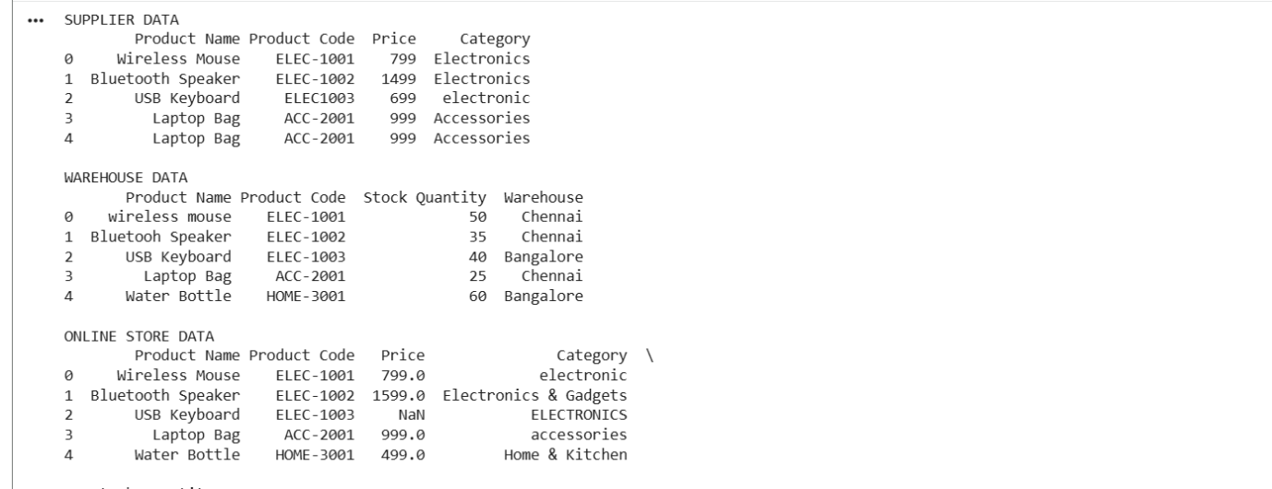
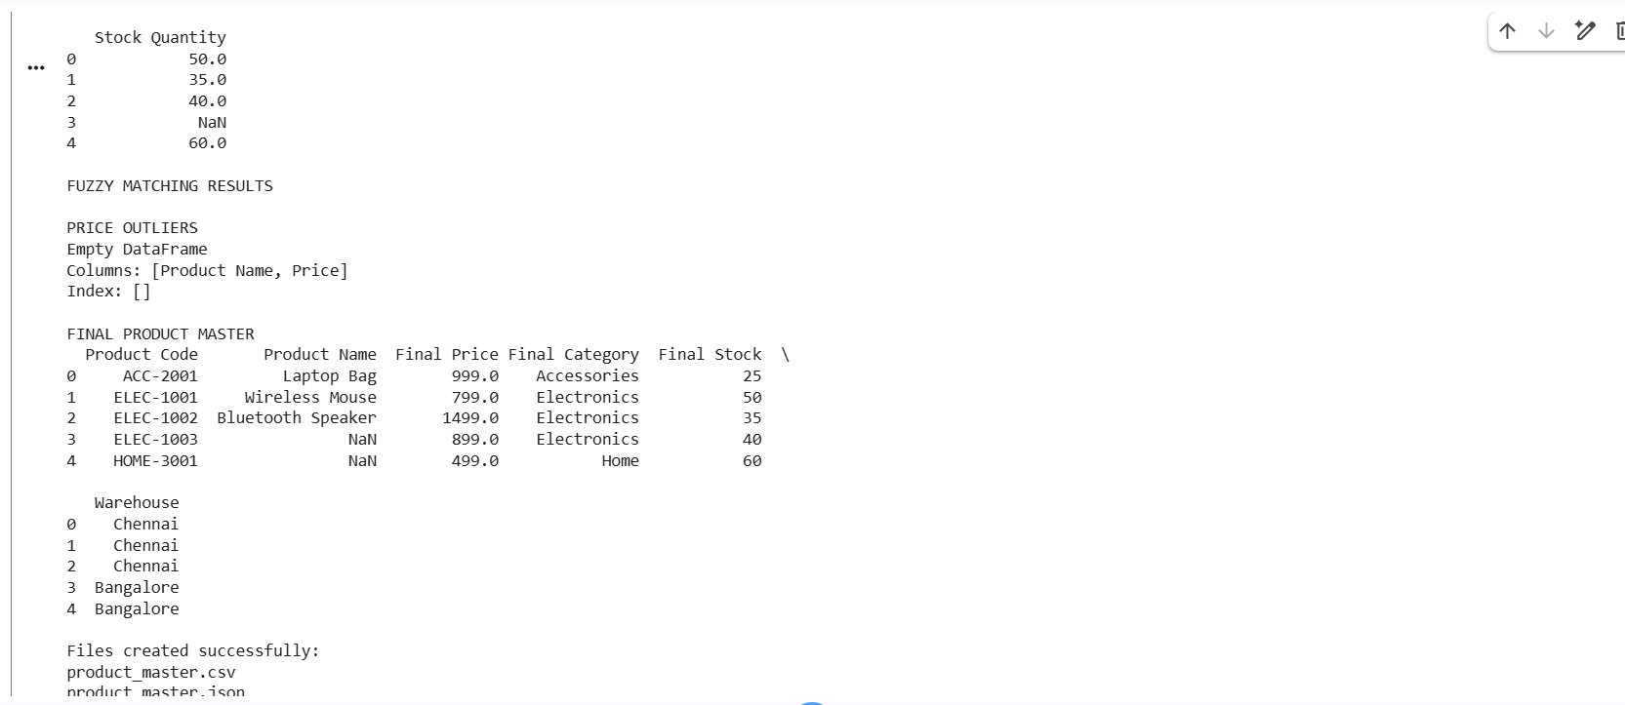
Result
The Supplier, Warehouse, and Online Store datasets were successfully cleaned and integrated using Python. Invalid product codes, duplicates, spelling variations, inconsistent categories, missing values, price outliers, and numerical inconsistencies were handled. The final Product Master dataset was successfully generated in CSV and JSON formats.
QUESTION 4 – STUDENT DATASET INTEGRATION
Aim
To clean and integrate Admission, Examination, and Attendance student datasets by handling spelling variations, different register number formats, inconsistent dates, invalid emails, missing values, duplicates, and formatting issues using Python and Pandas.
Python Program
!pip install rapidfuzz -q
import pandas as pd
import re
from rapidfuzz import fuzz
# =========================================================
# 2. STANDARDIZE STUDENT NAMES
# =========================================================
def clean_name(name):
name = str(name).strip()
name = re.sub(r'\s+', ' ', name)
return name.title()
for df in [admission, examination, attendance]:
df["Student Name"] = df["Student Name"].apply(
clean_name
)
# =========================================================
# 3. STANDARDIZE REGISTER NUMBERS
# =========================================================
def clean_register(reg):
reg = str(reg).upper()
reg = re.sub(r'[^A-Z0-9]', '', reg
# Convet AD23001 -> 23AD001
match = re.match(r'AD(\d{2})(\d{3})$', reg)
if match:
return match.group(1) + "AD" + match.group(2)
# Convert 23AD001
match = re.match(r'(\d{2})AD(\d{3})$', reg)
if match:
return match.group(1) + "AD" + match.group(2)
return reg
for df in [admission, examination, attendance]:
df["Register No"] = df["Register No"].apply(
clean_register
)
# =========================================================
# 4. DATE STANDARDIZATION
# =========================================================
admission["Date of Birth"] = pd.to_datetime(
admission["Date of Birth"],
errors="coerce",
dayfirst=True
)
admission["Date of Birth"] = (
admission["Date of Birth"]
.dt.strftime("%Y-%m-%d")
)
# =========================================================
# 5. EMAIL VALIDATION USING REGEX
# =========================================================
email_pattern = (
r'^[A-Za-z0-9._%+-]+@'
r'[A-Za-z0-9.-]+\.[A-Za-z]{2,}$'
)
def validate_email(email):
return bool(
re.match(
email_pattern,
str(email)
)
)
admission["Valid Email"] = admission[
"Email"
].apply(validate_email)
# Replace invalid emails with missing value
admission.loc[
~admission["Valid Email"],
"Email"
] = None

# =========================================================
# 6. HANDLE MISSING VALUES
# =========================================================
admission["Email"] = admission[
"Email"
].fillna("Not Available")
# =========================================================
# 7. IDENTIFY DUPLICATE STUDENTS
# =========================================================
duplicates = admission[
admission.duplicated(
subset=["Register No"],
keep=False
)
]
print("DUPLICATE STUDENTS")
print(duplicates)
# Remove duplicates
admission = admission.drop_duplicates(
subset="Register No"
)
# =========================================================
# 8. FUZZY MATCHING OF STUDENT NAMES
# =========================================================
print("\nFUZZY NAME MATCHING")
for i in range(len(examination)):
exam_name = examination.iloc[i]["Student Name"]

for j in range(len(admission)):
admission_name = admission.iloc[j]["Student Name"
score = fuzz.ratio(
exam_name.lower(),
admission_name.lower()
)
if score >= 85 and exam_name != admission_name:
print(
exam_name,
"<->",
admission_name,
"Similarity:",
round(score, 2)
)
# =========================================================
# 9. NORMALIZE NUMERICAL VALUES
# =========================================================
examination["Marks"] = pd.to_numeric(
examination["Marks"],
errors="coerce"

attendance["Attendance"] = pd.to_numeric(
attendance["Attendance"],
errors="coerce"
)
# Handle missing numerical values
examination["Marks"] = examination[
"Marks"
].fillna(
examination["Marks"].median()
)
attendance["Attendance"] = attendance[
"Attendance"
].fillna(
attendance["Attendance"].median()
)
# =========================================================
# 10. INTEGRATE ADMISSION + EXAMINATION
# =========================================================
master = pd.merge(
admission,
examination[
[
"Register No",
"Marks"
]
],
on="Register No",
how="outer"
)
# =========================================================
# 11. INTEGRATE ATTENDANCE
# =========================================================
master = pd.merge(
master,
attendance[
[
"Register No",
"Attendance"
]
],
on="Register No",
how="outer"
)
# =========================================================
# 12. FINAL CLEANUP
# =========================================================
master["Student Name"] = master[
"Student Name"
].fillna("Unknown")
master["Marks"] = master[
"Marks"
].fillna(0)

master["Attendance"] = master[
"Attendance"
].fillna(0)
# Remove duplicate register numbers
master = master.drop_duplicates(
subset="Register No"
)
# =========================================================
# 15. DISPLAY RESULT
# =========================================================

print("\nMASTER STUDENT DATASET")
print(student_master)

print("\nMaster CSV and JSON files created successfully.")
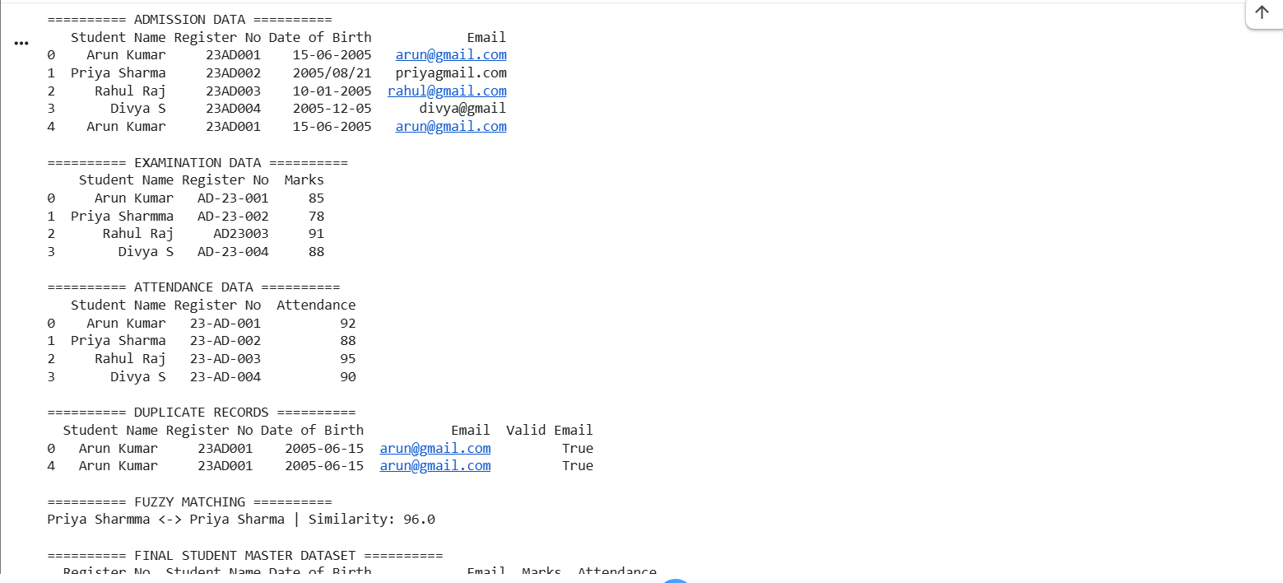
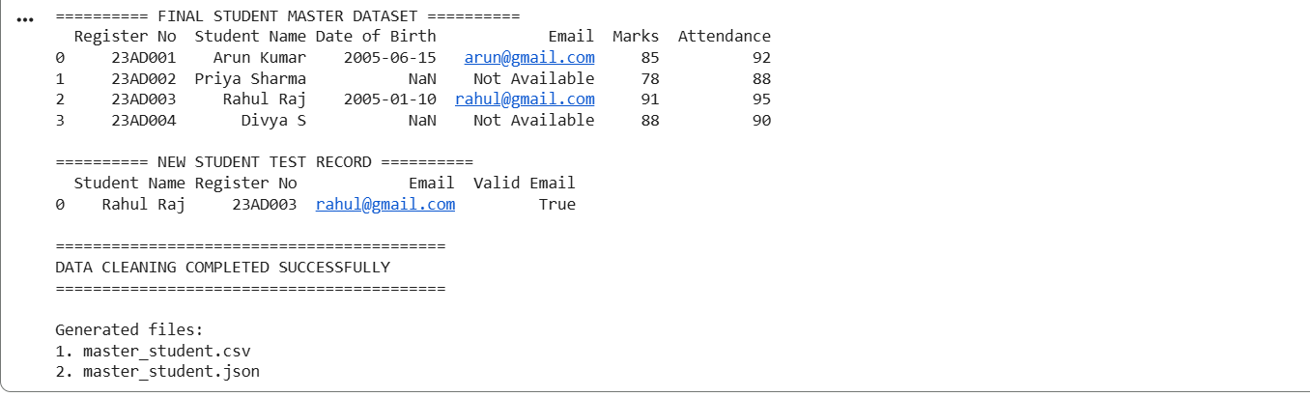
Result
The Admission, Examination, and Attendance datasets were successfully cleaned and integrated. Student names, register numbers, dates, emails, marks, and attendance were standardized. Duplicate records and invalid emails were identified, while fuzzy matching was used to detect spelling variations. A reusable cleanup process was created and tested with new student records.

